**Final Project: Hospital Management System**

Diva Kasa- 002619554

Thranathi Reddy Chada – 002673149

Satya Siva Sai Mrudula Chilukuri – 002644914

Platform: NetBeans

The Java Swing Framework is the application's basis. Utilization Purposes:

1.Our hospital management system provides a platform for individuals to receive medical treatment, register themselves, and receive assistance in times of need.

2. The system is managed by a hospital administrator who oversees the registration of doctors, nurses, and receptionists.

3.Patients can easily register themselves and choose a convenient appointment time by reviewing the doctor's schedule.

4.Receptionist confirms the appointment time with the patient through an email service where the patient is notified of the time of appointment.

5.Before the appointment, a nurse will take vital signs

6. The doctor will then examine the patient and prescribe any necessary tests and medications.

7.The pharmacist is responsible for maintaining the inventory of medicines, restocking medicines, and dispensing them to patients as prescribed by the doctor.

8.The lab technician is responsible for adding tests that can be performed, performing tests on patients, and updating the test results that can be accessed by both the doctor and the patient. 9.Additionally, patients can choose an insurance plan to receive discounts on medical bills. The insurance agent will review the enrollment request and either accept or reject it.

10. Overall, our hospital management system offers a variety of medical services and features.

Contributions:

We have divided 4 enterprises (Hospital, pharmacy, lab, insurance company) among ourselves and collaborated on the cross- work requests.

Charts has been worked by Mrudula Chilukuri , Email function has been worked by Divya Kasa and Documentation and diagrams has been handled by Thranathi.

**Architecture Model:**

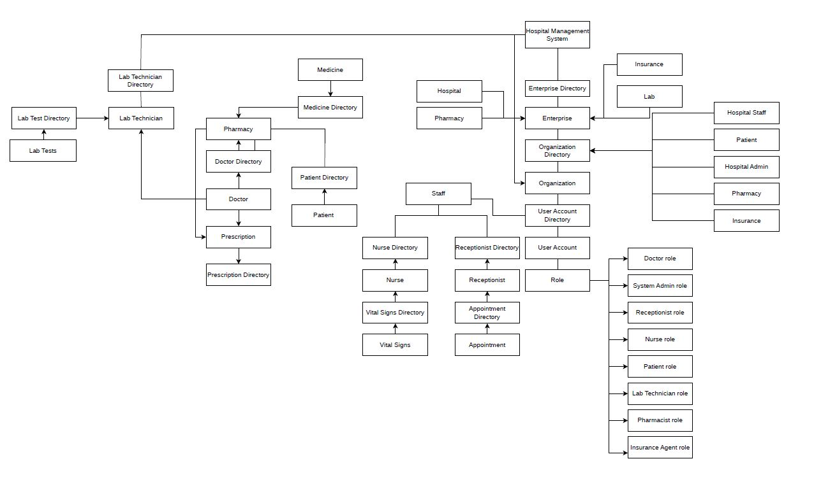

Class Diagram:

